HEALTH – AI CONSULTANT AND ASSISTANT
A project work submitted to the Jamal Mohamed College (Autonomous), Tiruchirappalli in partial fulfillment of the requirements for the award of the degree of

BACHELOR OF COMPUTER APPLICATIONS
by
IRFAN GOWSAR A – 23UCA102
Guided by

Dr. INBARAJ, M.C.A., M.Phil, Ph.D.,



DEPARTMENT OF COMPUTER APPLICATIONS
JAMAL MOHAMED COLLEGE (Autonomous)
Accredited with A++ Grade by NAAC (4th Cycle) with CGPA 3.69 out of 4.0
(Affiliated to Bharathidasan University)

TIRUCHIRAPPALLI – 620 020

MARCH 2026

JAMAL MOHAMED COLLEGE (Autonomous)
Accredited with A++ Grade by NAAC (4th Cycle) with CGPA 3.69 out of 4.0
(Affiliated to Bharathidasan University)
TIRUCHIRAPPALLI – 620 020

This is to certify that this project work entitled

“HEALTH – AI CONSULTANT AND ASSISTANT”
is a Bonafide record of the project work done
by
IRFAN GOWSAR A – 23UCA089
at Jamal Mohamed College (Autonomous), Tiruchirappalli during the year 2025-2026 in partial fulfillment of the requirements for the award of the degree of
BACHELOR OF COMPUTER APPLICATIONS

Dr. INBARAJ, M.C.A., M.Phil, Ph.D., Dr. M. KAMAL
Assistant professor Head of the Department

submitted for the Viva Voce examination held at Jamal Mohamed College, Tiruchirappalli on ______________.

Internal Examiner External Examiner

Dr. INBARAJ, M.C.A., M.Phil, Ph.D.,
Assistant professor,
COMPUTER APPLICATIONS,
Jamal Mohamed College (Autonomous),
Tiruchirappalli – 620 020.

CERTIFICATE

This is to certify that this project entitled ”HEALTH AI CONSULTANT AND ASSISTANT”
submitted in partial fulfillment of the requirements for the award of the degree of Bachelor of Computer Applications to the Jamal Mohamed College, Tiruchirappalli is a Bonafide record of the work done by IRFAN GOWSAR A (Reg.No: 23UCA089) under my supervision and guidance.

Date : Signature of the Guide

CONTENTS Page No.
ACKNOWLEDGEMENTS 5
ABSTRACT 6
- INTRODUCTION 7
  - Problem Definition

- PROBLEM DESCRIPTION 10

- SYSTEM STUDY 13
  - Existing System
  - Proposed System
  - Need for Computerization
  - Data Flow Diagrams
  - Data Dictionary

- SYSTEM CONFIGURATION 20
  - Hardware Requirements
  - Software Requirements

- OVERVIEW OF THE SOFTWARE 24

- DESIGN AND DEVELOPMENT 27
  - Architectural Design
  - Database Design
  - Input and Output Design

- IMPLEMENTATION AND TESTING 33

- CONCLUSION 38
BIBLIOGRAPHY 41
ANNEXURE 42
A SOURCE CODE 43
B SCREEN INTERFACES 82
REPORT 88
ACKNOWLEDGEMENTS

Gratitude is a sense of thankfulness to the hands that stretched out towards us in help. At the onset, I am grateful to the Lord Almighty who has showered his grace and enlightened me through this project. A journey of thousand miles begins with a single step. Words are inadequate to express my heartiest, sincere and grateful thanks to the following persons.
I first express my deepest gratitude to my teachers, well-wishers and parents who are all my strength and provide constant support in each step.

My sincere thanks to Dr. D. I. George Amalarethinam, M.C.A., M.Phil., P.G.D.B.A.,Ph.D., Principal, Jamal Mohamed College, Tiruchirappalli who provided this opportunity and for his catalytic and constant encouragement.

High among the kings is the emperor with bright visions and novel ideas. I extend my thanks to Dr. G. Ravi, M.C.A., P.G.D.B.A., M.Phil., Ph.D., Coordinator, Department of Computer Applications, and Dr. M. Kamal, M.Sc., M.Phil., Ph.D., Member in charge, Department of Computer Applications for their support and encouragement.

As the pole star guides every lonely traveler with assurance and safety, so has my guide, I extend my sincere thanks to Dr. INBARAJ, M.C.A., M.Phil, Ph.D. for all his guidance, encouragement, motivation and inspiration that enabled me to shine every walk of life.

At the outset I wish to convey my sincere thanks to the staff members of Computer Science Department and all my friends who guided in my endeavor.

ABSTRACT

HealthGenie AI is an intelligent web-based healthcare assistant designed to help users analyze symptoms and receive basic health guidance through an interactive chatbot system. The main objective of this project is to provide a simple AI-powered medical consultation interface that allows users to describe their symptoms and receive possible health insights instantly.
The system is developed using Python and Flask for the backend, SQLite for database management, and HTML, Tailwind CSS, and JavaScript for the frontend interface. HealthGenie AI includes features such as user authentication, AI symptom analysis, medical report generation, and an administrator panel to monitor user activity.
The AI chatbot analyzes user-entered symptoms using a rule-based medical dataset containing various symptoms and potential conditions. Based on the detected symptoms, the system evaluates risk levels and generates health suggestions along with a health score. The platform also allows users to view their chat history and generate a medical summary report based on previous interactions.
The admin panel provides the ability to manage users and analyze platform usage, making the system structured and manageable. The overall goal of HealthGenie AI is to demonstrate how artificial intelligence can assist in preliminary health assessment and digital healthcare support.
This project highlights the practical use of AI-driven decision systems in healthcare and showcases how intelligent applications can improve accessibility to basic health consultation services.

INTRODUCTION

In today’s fast-paced world, maintaining good health has become more important than ever. With increasing academic pressure, busy schedules, and the widespread use of technology, people—especially students and young individuals—often overlook the importance of taking proper care of their physical and mental well-being. Health is not only the absence of illness but also a state of complete physical, mental, and social well-being. Because of this, many modern tools and ideas have been developed to help people manage their health more easily and effectively. One such concept is Health Genie, a system or platform designed to guide individuals in making better health decisions and maintaining a balanced lifestyle.
The idea behind Health Genie is similar to having a helpful guide or “genie” that provides useful health advice whenever needed. Instead of searching through many different sources, users can rely on a single platform that offers clear, practical, and reliable information about health. Health Genie can include features such as health tips, fitness suggestions, reminders for healthy habits, and guidance about nutrition, sleep, and exercise. By combining technology with health knowledge, Health Genie aims to make healthy living simpler and more accessible for everyone.
In many cases, people know that they should eat healthier foods, exercise regularly, and get enough sleep, but they may not always know how to start or stay consistent. Health Genie addresses this problem by providing simple recommendations and daily guidance. For example, it may remind users to drink enough water, suggest short exercises they can do at home, or encourage them to take breaks during long study sessions. These small actions, when practiced regularly, can lead to significant improvements in overall health and well-being.

Another important aspect of Health Genie is education. Many health problems arise because people lack basic knowledge about healthy habits. By providing clear explanations and helpful information, Health Genie can teach users about topics such as balanced diets, the importance of physical activity, stress management, and maintaining good hygiene. When individuals understand how their daily choices affect their bodies and minds, they are more likely to adopt healthier behaviors.
Health Genie can also play a role in promoting preventive healthcare. Prevention is often easier and more effective than treating illnesses after they occur. Through reminders, tips, and early awareness, Health Genie can encourage users to develop habits that reduce the risk of common health issues. These habits might include regular exercise, eating nutritious foods, maintaining a proper sleep schedule, and managing stress in healthy ways. By focusing on prevention, Health Genie supports a proactive approach to health rather than a reactive one.
Technology has made it possible for health guidance to become more personalized as well. A Health Genie system may adapt its suggestions based on a user’s age, lifestyle, goals, and preferences. For example, a student might receive tips for staying focused during study sessions and maintaining energy throughout the day, while someone interested in fitness might receive workout suggestions or progress tracking. This personalized approach makes the advice more relevant and easier to follow.
In addition to physical health, Health Genie can support mental and emotional well-being. Modern life often brings stress, anxiety, and pressure from school, work, or social expectations. By offering strategies for relaxation, mindfulness, and healthy routines, Health Genie can help users maintain a balanced state of mind. Encouraging positive habits such as regular sleep, time management, and breaks from excessive screen use can make a big difference in a person’s overall well-being.

Furthermore, Health Genie can encourage individuals to take responsibility for their own health. Rather than depending entirely on others for guidance, users can learn to monitor their habits and make informed decisions. This sense of awareness and responsibility can lead to lifelong healthy behaviors. When people feel empowered with knowledge and practical tools, they are more confident in managing their own well-being.
Another benefit of Health Genie is its accessibility. With smartphones, computers, and other digital devices widely available, health information can be delivered quickly and conveniently. This makes it easier for individuals from different backgrounds to access useful guidance whenever they need it. Whether someone is looking for a quick fitness tip, advice on staying hydrated, or ideas for healthier meals, Health Genie can provide helpful support in everyday situations.
In conclusion, Health Genie represents a modern approach to health guidance that combines technology, knowledge, and daily support. By offering practical advice, promoting healthy habits, and encouraging preventive care, it aims to help individuals live healthier and more balanced lives. As people continue to face challenges related to busy lifestyles and increasing health concerns, tools like Health Genie can play an important role in making health management simpler, smarter, and more accessible for everyone.

PROBLEM DESCRIPTION

Healthcare is one of the most important aspects of human life. However, many people around the world still struggle to access reliable medical information and basic health guidance. In many cases, people do not know whether their symptoms require medical attention or simple home care. Lack of awareness, limited access to doctors, long waiting times in hospitals, and high medical costs often prevent individuals from getting timely healthcare support.
With the rapid development of digital technology, there is an opportunity to use smart systems and applications to assist people with basic health information and guidance. The Health Genie Project is designed to address these issues by providing a digital platform that helps users understand health symptoms, receive basic medical guidance, and access health-related information quickly and easily.

2.1 BACKGROUND OF THE PROBLEM

Many individuals rely on random internet searches or unreliable sources when they experience health symptoms. This can lead to confusion, misinformation, or unnecessary panic. For example, a simple headache might be mistaken for a serious illness, or serious symptoms might be ignored because the person lacks proper knowledge.
In rural or remote areas, the situation is even more challenging. People may have limited access to hospitals, clinics, or professional healthcare providers. Traveling to a medical facility may take a long time and cost money. As a result, individuals often delay seeking medical help until their condition becomes worse.

Another major problem is the overload in hospitals and clinics. Doctors often have limited time to attend to every patient, especially for minor health concerns that could be managed with proper guidance. If there were a system that could help people understand basic health issues and recommend when to seek professional care, it could reduce unnecessary hospital visits and improve healthcare efficiency.

2.2 PROBLEM STATEMENT

The main problem addressed by the Health Genie Project is the lack of accessible, reliable, and quick health guidance for individuals experiencing basic health symptoms. Many people do not have immediate access to medical advice, and the absence of trustworthy information can lead to poor health decisions.
The Health Genie Project aims to provide a digital solution that helps users identify possible health conditions based on symptoms, offers general health advice, and guides them on whether they should seek professional medical assistance.

2.3 CHALLENGES FACED BY USERS

There are several challenges that individuals face regarding health information and healthcare access:
- Limited Access to Healthcare Professionals
Many people cannot easily consult a doctor due to distance, time constraints, or financial limitations.
- Lack of Reliable Health Information
People often depend on unreliable online sources or social media, which may provide incorrect or misleading medical information.
- Delayed Medical Attention
Because people are unsure about the seriousness of their symptoms, they may delay seeking medical care.
2.4 IMPORTANCE OF SOLVING THE PROBLEM

Addressing these problems is essential for improving overall public health and promoting better healthcare awareness. A system like Health Genie can empower individuals with knowledge about their health conditions and encourage them to take appropriate actions.
Providing easy access to health information can help people make better decisions, reduce anxiety about symptoms, and encourage early detection of potential health issues. Additionally, digital health tools can support healthcare systems by reducing unnecessary visits to hospitals and clinics.

2.5 PURPOSE OF THE HEALTH GENIE PROJECT

The purpose of the Health Genie Project is to create a user-friendly digital platform that assists users in understanding their health conditions and provides reliable health-related information. The system will allow users to enter symptoms and receive possible explanations or guidance based on those symptoms.
The project also aims to educate users about healthy lifestyle practices, disease prevention, and when to seek professional medical help. By providing accurate and accessible information, the Health Genie system can support individuals in managing their health more effectively.

2.6 EXPECTED IMPACT

If implemented successfully, the Health Genie Project can have several positive impacts. It can improve public health awareness, help individuals make informed health decisions, and reduce pressure on healthcare facilities. The system can also serve as a helpful first step for people who are unsure about their symptoms or health concerns.
In the long term, digital health platforms like Health Genie can contribute to smarter healthcare systems where technology supports both patients and medical professionals.

SYSTEM STUDY
3.1 EXISTING SYSTEM

The existing healthcare support system mainly relies on traditional medical consultation and manual methods of obtaining health information. When individuals experience symptoms or health problems, they usually visit a hospital, clinic, or healthcare professional to get medical advice and treatment. In some situations, people also search for health-related information on the internet through various websites and social media platforms.

Although these methods provide access to medical knowledge, they have several limitations. Hospitals and clinics often face a large number of patients every day, which results in long waiting times for consultations. Patients with minor health issues also need to wait for long periods even though their problems may not require immediate medical attention. This situation increases the workload of doctors and healthcare staff.

Another challenge of the existing system is the limited accessibility of healthcare services in rural and remote areas. Many people living in such areas do not have easy access to hospitals or qualified doctors. They may have to travel long distances to receive basic medical consultation, which can delay treatment and increase health risks.

In addition, many individuals depend on random websites to understand their symptoms. The information available on the internet is not always reliable or verified by medical professionals. As a result, people may misunderstand their symptoms and follow incorrect advice, which can negatively affect their health.
The existing system also lacks a quick preliminary guidance mechanism that can help users understand whether their symptoms require immediate medical attention or simple preventive measures. Because of this limitation, people either ignore their symptoms or unnecessarily visit hospitals.

Furthermore, manual healthcare consultation does not always provide continuous health awareness. People usually seek medical help only when they feel sick, rather than taking preventive steps to maintain good health.
Limitations of the Existing System
- Lack of instant access to health guidance
- Dependence on hospital visits for minor health issues
- Long waiting times in healthcare facilities
- Limited availability of doctors in rural areas
- Risk of incorrect information from unreliable online sources
- Lack of preventive health awareness systems
Due to these challenges, there is a strong need for a smart and computerized system that can provide quick and reliable health information to users anytime and anywhere.

3.2 PROPOSED SYSTEM

The proposed system for this project is Health Genie, a digital health assistance platform designed to provide users with quick and basic health guidance based on the symptoms they enter. The main objective of this system is to help users understand possible health conditions and receive general advice before consulting a medical professional.

The Health Genie system allows users to interact with the application through a simple and user-friendly interface. Users can enter their symptoms, personal details such as age or gender if required, and the system will analyze the information using its internal health knowledge database.

Based on the entered symptoms, the system will generate possible health suggestions and provide precautionary advice. This information can help users understand whether their condition may require medical consultation or whether simple preventive measures can be followed at home.

One of the key advantages of the proposed system is its ability to provide instant responses. Unlike traditional healthcare consultation where patients need to wait for appointments or travel to hospitals, the Health Genie system allows users to receive basic health guidance within seconds.

The system also focuses on health awareness and preventive care. It can provide users with tips about maintaining a healthy lifestyle, such as proper diet, regular exercise, and general wellness practices. This helps users become more aware of their health and encourages preventive healthcare.

Another important feature of the proposed system is its ability to store and manage data effectively. User interactions, symptoms, and system suggestions can be recorded in a database for analysis and improvement of the system.

It is important to note that the Health Genie system does not replace doctors or professional medical diagnosis. Instead, it acts as a support tool that provides preliminary health information and guides users toward making better healthcare decisions.

Advantages of the Proposed System
- Instant health guidance
- Easy-to-use interface
- Reduced unnecessary hospital visits
- Increased health awareness
- Accessible from anywhere through digital devices
- Better data storage and management
The proposed system aims to improve access to healthcare information and provide users with quick assistance in understanding their symptoms.

3.3 NEED FOR COMPUTERIZATION
Computerization plays an important role in modern healthcare systems. With the rapid growth of digital technology, computerized solutions are widely used to improve efficiency, accuracy, and accessibility in various fields, including healthcare.

The traditional healthcare system mainly depends on manual consultation and physical visits to hospitals. While this approach is essential for proper diagnosis and treatment, it can sometimes be slow and inconvenient for people who only need basic health guidance.

Computerization allows healthcare information systems to operate more efficiently. By using computerized systems like Health Genie, users can obtain health-related information quickly without the need for physical visits.

One of the main reasons for computerization is speed. Digital systems can process information rapidly and provide results instantly. This helps users save time and effort when searching for health advice.

Another important reason is data management. Computerized systems can store large amounts of information in databases, making it easier to retrieve and analyze data whenever needed. This improves the overall organization and accessibility of information.
Computerization also improves accuracy and reliability. Instead of relying on random internet searches, users can access structured and verified information stored in the system's database.

Accessibility is another important advantage. With computerized systems, users can access services through computers, smartphones, or other digital devices. This is especially useful for people living in remote areas where healthcare facilities are limited.

In addition, computerized systems can support continuous improvement. Data collected from users can help developers analyze common symptoms and improve the system’s recommendations over time.

Benefits of Computerization
- Faster access to information
- Improved data storage and management
- Increased accessibility for users
- Reduced workload on healthcare professionals
- Better organization of healthcare data
- Support for digital healthcare solutions
Therefore, computerization is essential for developing efficient healthcare support systems like Health Genie.

3.4 DATA FLOW DIAGRAMS (DFD)

A Data Flow Diagram (DFD) is a graphical representation that shows how data moves through a system. It helps in understanding the flow of information between different processes, data stores, and external entities within the system.

DFDs are commonly used in system analysis and design to visualize how a system processes data and how different components interact with each other.

In the Health Genie system, the DFD illustrates how user inputs are processed by the system to generate health suggestions and advice.

Level 0 – Context Diagram
The Level 0 DFD, also known as the Context Diagram, represents the overall system as a single process and shows its interaction with external entities.

In the Health Genie system, the main external entity is the User. The user interacts with the system by entering symptoms and receiving health suggestions.

The process flow in the context diagram works as follows:
- The user enters symptoms into the Health Genie system.
- The system receives the input data.
- The system processes the symptoms using its health database.
- The system generates health suggestions and advice.
- The results are displayed to the user.
This diagram provides a high-level view of how the Health Genie system operates.

Level 1 – Data Flow Diagram
The Level 1 DFD provides a more detailed representation of the processes within the system.

In the Health Genie system, the main processes include:
- User Symptom Input – The user enters symptoms and personal details.
- Symptom Processing – The system analyzes the symptoms.
- Database Access – The system searches the health database for related information.
- Advice Generation – The system generates possible health suggestions and precautions.
- Result Display – The system presents the information to the user.

The system also includes several data stores such as:
- User Information Database
- Symptoms Database
- Health Advice Database

The DFD helps developers understand how data flows through the system and ensures that all processes are clearly defined.

3.5 DATA DICTIONARY
A Data Dictionary is a structured list that describes all data elements used within a system. It provides detailed information about the data such as its name, type, description, and how it is used in the system.
In the Health Genie project, the data dictionary helps developers and system designers understand the structure of the data used in the system. It also ensures consistency when storing and processing information.
Data Dictionary Table
Data Element | Description | Data Type
User_ID | Unique identification number for each user | Integer
User_Name | Name of the user | Text
Age | Age of the user | Integer
Gender | Gender of the user | Text
Symptoms | Symptoms entered by the user | Text
Symptom_ID | Unique identifier for symptoms | Integer
Disease_Result | Possible disease suggested by the system | Text
Health_Advice | Suggested precautions or recommendations | Text
Date | Date of system interaction | Date

SYSTEM CONFIGURATION

4.1 HARDWARE REQUIREMENTS

Hardware requirements refer to the physical components needed to develop, run, and maintain the Health Genie system. Since the Health Genie project is a software-based application that provides health guidance based on user symptoms, it does not require highly advanced or expensive hardware. However, certain basic hardware components are necessary to ensure that the system operates smoothly and efficiently.

The system can be developed and executed using a standard computer system with moderate processing power. A computer with a reliable processor, sufficient memory, and adequate storage capacity is essential for running the development tools and managing the system database. The hardware requirements ensure that the system performs well during development, testing, and execution.

One of the most important hardware components is the processor (CPU). The processor is responsible for executing the instructions required to run the software and perform system operations. A modern processor such as Intel Core i3, AMD Ryzen 3, or higher is sufficient for developing and running the Health Genie system.

Another important component is Random Access Memory (RAM). RAM allows the computer to temporarily store data that is actively being used by the system. Adequate RAM ensures smooth performance when running programming environments, databases, and system processes simultaneously. A minimum of 4 GB RAM is recommended, although 8 GB RAM provides better performance and stability.

The system also requires sufficient storage capacity to store application files, databases, and development tools. A minimum of 256 GB storage is recommended. Solid State Drives (SSD) are preferred because they provide faster data access and improve overall system performance compared to traditional hard drives.

Input and output devices are also necessary for interacting with the system. These include a keyboard and mouse for entering data and controlling the system interface. A monitor is required to display the user interface, system outputs, and development environment.

Internet connectivity is another useful hardware-related requirement, especially during development. Internet access allows developers to download libraries, access documentation, and update software tools. It may also be useful if the system connects to online health information resources.

Minimum Hardware Requirements
- Processor: Intel Core i3 / AMD equivalent or higher
- RAM: 4 GB minimum (8 GB recommended)
- Storage: 256 GB Hard Disk / SSD
- Monitor: Standard display monitor
- Input Devices: Keyboard and Mouse
- Internet Connection: Required for development and updates

These hardware components are sufficient to develop, test, and run the Health Genie system efficiently. Since the project is mainly software-based, the hardware requirements remain relatively simple and cost-effective.

4.2 SOFTWARE REQUIREMENTS

Software requirements refer to the programs, tools, and operating systems needed to develop and operate the Health Genie system. The correct selection of software tools is important because they support coding, testing, database management, and system deployment.

The primary software requirement is an operating system that supports development tools and application execution. Common operating systems such as Windows, Linux, or macOS can be used. For this project, Windows is typically preferred because it supports a wide range of development tools and is widely used in educational environments.

Another important software component is the programming environment or development platform used to build the Health Genie application. Depending on the implementation, languages such as Python, Java, or web-based technologies like HTML, CSS, and JavaScript may be used to create the user interface and system logic.

A code editor or Integrated Development Environment (IDE) is also required for writing and managing the program code. Popular development tools include Visual Studio Code, PyCharm, Eclipse, and IntelliJ IDEA. These tools provide features such as syntax highlighting, debugging tools, and project management capabilities that make software development easier and more efficient.

Database management software is another essential component of the system. The Health Genie project requires a database to store user data, symptom information, and health advice records. Databases such as MySQL, SQLite, or PostgreSQL can be used to manage and organize the system data.

In addition, web browsers may be required if the system is implemented as a web-based application. Browsers like Google Chrome, Mozilla Firefox, or Microsoft Edge allow users to interact with the system through a graphical interface.

Testing tools may also be used during development to ensure that the system works correctly. These tools help developers identify errors, test system functions, and improve overall performance.

Software Requirements Summary
- Operating System: Windows / Linux / macOS
- Programming Language: Python / Java / Web Technologies (HTML, CSS, JavaScript)
- Development Environment: Visual Studio Code, PyCharm, or Eclipse
- Database Management System: MySQL / SQLite / PostgreSQL
- Web Browser: Google Chrome / Mozilla Firefox / Microsoft Edge

These software tools provide the necessary environment for designing, developing, testing, and deploying the Health Genie system. Using reliable and widely supported software ensures that the project can be maintained and improved in the future.

OVERVIEW OF THE SOFTWARE

Health Genie is a digital health assistance software system designed to provide users with basic health guidance based on the symptoms they enter. The main objective of the Health Genie software is to help users understand possible health conditions and receive preliminary advice before seeking professional medical consultation. With the increasing use of digital technology in healthcare, systems like Health Genie can support individuals in becoming more aware of their health and making better healthcare decisions.

The Health Genie software works as an intelligent system that interacts with users through a simple and user-friendly interface. Users can enter their symptoms into the system, and the software processes this information by comparing it with a stored health knowledge database. Based on this analysis, the system generates possible health suggestions and precautionary advice that may help users understand their condition better.

One of the key purposes of this software is to provide quick and easily accessible health information. In many cases, people experience minor health symptoms but are unsure whether they need to visit a doctor. Health Genie helps users by providing preliminary guidance that can assist them in determining whether their symptoms may require medical attention or whether basic home care or preventive measures might be sufficient.

The software is designed to be simple so that users with limited technical knowledge can easily operate it. The interface allows users to enter information such as symptoms, age, or other relevant details. After receiving the input, the system processes the information using its internal logic and database, and then it displays the results in a clear and understandable format.

Another important aspect of the Health Genie software is its ability to improve health awareness among users. The system can provide useful information about maintaining a healthy lifestyle, including recommendations related to diet, physical activity, hydration, and general wellness practices. By providing such information, the software encourages users to adopt preventive healthcare habits.

The software also helps reduce the burden on healthcare facilities by minimizing unnecessary hospital visits. Many people visit hospitals for minor health concerns that could be managed through simple precautions. Health Genie provides basic advice that can guide users before they decide to seek professional medical assistance.

Health Genie is also designed with data management capabilities. The system can store user inputs, symptoms, and generated advice in a database. This stored data can help developers improve the system in the future by analyzing common health queries and updating the knowledge base with more accurate information.

Another advantage of the software is its flexibility and scalability. The system can be developed as a standalone application or as a web-based platform that can be accessed through computers, tablets, or smartphones. This flexibility allows the software to reach a larger number of users and provide health guidance anytime and anywhere.

The software development process involves several important components including the user interface, the symptom analysis module, and the health advice database. These components work together to ensure that the system functions efficiently and provides useful results to users.

The user interface is responsible for allowing users to interact with the system. It collects input data such as symptoms and displays the results generated by the system. The interface must be simple and easy to understand so that users can quickly enter their information and receive results.

The symptom analysis module is the core component of the software. This module processes the user input and compares it with the stored medical knowledge in the database. Based on this comparison, the system identifies possible health conditions and generates appropriate advice.

The health knowledge database contains information about symptoms, possible diseases, and general health recommendations. This database plays an important role in ensuring that the system provides meaningful and relevant information to users.

While Health Genie provides useful health guidance, it is important to understand that the system does not replace professional medical diagnosis or treatment. Instead, it acts as a supportive tool that helps users gain a basic understanding of their symptoms and encourages them to seek professional medical help when necessary.
Overall, the Health Genie software represents a modern approach to digital healthcare assistance. It combines technology and health information to create a platform that provides quick, accessible, and user-friendly health guidance. By helping users understand their symptoms and promoting preventive healthcare practices, the system contributes to improved health awareness and better decision-making.
In conclusion, Health Genie is an innovative software solution designed to support individuals in managing their health more effectively. By providing instant symptom-based guidance, easy accessibility, and a simple user interface, the software offers a practical and efficient way to obtain preliminary health information in today’s digital environment.

DESIGN AND DEVELOPMENT

The design and development phase is one of the most important stages in the software development process. In this phase, the structure of the system is planned and the components required for the system are designed. The purpose of system design is to convert the system requirements into a clear and organized structure that can be implemented through programming.

For the Health Genie system, the design focuses on creating a simple, efficient, and user-friendly system that can accept user symptoms, analyze them, and provide health suggestions. The design process includes architectural design, database design, and input and output design.

6.1 ARCHITECTURAL DESIGN

Architectural design refers to the overall structure of the system and the way different components interact with each other. It provides a high-level view of how the system functions and how the modules communicate to perform tasks.

The Health Genie system follows a modular architecture, where the system is divided into different components that perform specific functions. This structure improves system organization and makes it easier to develop, maintain, and update the software in the future.

The main components of the Health Genie architecture include the User Interface Module, Processing Module, and Database Module.

1. User Interface Module
The user interface module is responsible for interaction between the user and the system. It allows users to enter their symptoms and other required information. The interface also displays the results generated by the system.
The interface should be simple, clear, and easy to use so that users can quickly understand how to operate the system. It may include forms, buttons, and text fields that help users provide their input easily.

2. Symptom Processing Module
This module is responsible for analyzing the symptoms entered by the user. The system processes the input data and compares it with the information stored in the health database.
Based on this analysis, the system identifies possible health conditions and generates suggestions or precautionary advice. This module acts as the core logic of the Health Genie system.

3. Database Module
The database module stores all the information required for the system to function properly. It contains data such as symptom details, possible diseases, and recommended health advice.
Whenever the user enters symptoms, the system accesses the database to find related information. The results are then processed and displayed to the user.

4. Result Display Module
After processing the symptoms and retrieving information from the database, the system generates health suggestions and displays them to the user through the interface.
The architectural design ensures that the system operates efficiently and that each module performs its specific task without interfering with other components.

6.2 DATABASE DESIGN

Database design is an important part of system development because it defines how data is stored, organized, and accessed within the system. A well-structured database ensures that the system can retrieve and manage information efficiently.

In the Health Genie system, the database is designed to store information related to users, symptoms, diseases, and health advice. The database helps the system analyze symptoms and generate appropriate responses.

The database design includes several tables that are connected to each other. Each table stores specific types of data and contains fields that define the information stored in the table.

1. User Table
The user table stores information related to the users of the system. This information may include user ID, name, age, and gender.
Example fields:
- User_ID
- User_Name
- Age
- Gender
This information helps the system understand user profiles and manage user records.

2. Symptoms Table
The symptoms table contains a list of symptoms that can be entered into the system. Each symptom has a unique identification number.
Example fields:
- Symptom_ID
- Symptom_Name
- Symptom_Description
This table helps the system identify the symptoms entered by users.
3. Disease Table
The disease table stores information about possible diseases related to specific symptoms.
Example fields:
- Disease_ID
- Disease_Name
- Related_Symptoms
This information allows the system to match symptoms with possible health conditions.
4. Health Advice Table
This table contains general health recommendations and precautionary advice related to different diseases or symptoms.
Example fields:
- Advice_ID
- Disease_ID
- Health_Advice
The database structure ensures that the system can quickly retrieve relevant information and provide useful guidance to users.

6.3 INPUT AND OUTPUT DESIGN

Input and output design is an important aspect of system development because it determines how users interact with the system and how information is presented to them.
A good input and output design improves usability and ensures that the system functions efficiently.

Input Design
Input design refers to the way users provide information to the system. The goal of input design is to make data entry simple, accurate, and user-friendly.
In the Health Genie system, users enter their symptoms through input forms provided by the system interface.
The input interface may include the following fields:
- User Name
- Age
- Gender
- Symptoms

The system may also provide a list of common symptoms so that users can select them easily instead of typing them manually.
Good input design reduces errors and ensures that the system receives correct and useful information for processing.

Output Design
Output design refers to the way the system presents information or results to the user. The output should be clear, understandable, and helpful.
In the Health Genie system, the output includes health suggestions, possible conditions, and precautionary advice based on the symptoms entered by the user.
The output may include:
- Possible health condition
- Recommended precautions
- General health advice
- Suggestion to consult a doctor if necessary
The results should be displayed in a structured format so that users can easily understand the information provided by the system.
The main goal of output design is to provide users with useful information that helps them make better health decisions.

IMPLEMENTATION AND TESTING

7.1 IMPLEMENTATION

Implementation is the stage of the software development process where the designed system is converted into a working application. During this phase, the system design is translated into actual program code, and all modules of the system are developed and integrated. The main objective of implementation is to ensure that the Health Genie system works according to the design specifications and performs its intended functions effectively.
For the Health Genie project, the implementation phase involved developing the different modules of the system such as the user interface, symptom analysis module, database management system, and output display module. These modules work together to provide users with health suggestions based on the symptoms they enter.
The development process started with creating the user interface, which allows users to interact with the system. The interface was designed to be simple and user-friendly so that users can easily enter their symptoms and receive results without difficulty. The interface includes input fields where users can provide information such as their symptoms and other basic details.
After the user interface was developed, the next step involved implementing the symptom processing logic. This module is responsible for analyzing the symptoms entered by the user. The system compares the input symptoms with the information stored in the database and determines possible health conditions related to those symptoms.
The database module was also implemented to store the necessary information required by the system. The database contains details about symptoms, possible diseases, and recommended health advice. When a user enters symptoms, the system retrieves the relevant information from the database and processes it to generate suggestions.

Another important part of implementation was integrating the different modules of the system. Integration ensures that all components communicate properly and work together as a single system. For example, when a user enters symptoms through the interface, the data must be sent to the processing module, which then accesses the database and generates the output.
The implementation phase also involved writing clean and well-structured code to ensure that the system functions efficiently. Proper coding practices were followed to make the system easy to maintain and update in the future.
In addition, attention was given to system performance and usability. The system was designed to respond quickly to user inputs and provide results in a clear and understandable format. The output results are displayed in an organized manner so that users can easily interpret the health advice provided by the system.
Overall, the implementation phase successfully transformed the system design into a functional software application. The completed Health Genie system provides users with a platform where they can enter symptoms and receive health suggestions quickly and conveniently.

7.2 SYSTEM TESTING

Testing is an essential stage of the software development process. The purpose of testing is to ensure that the system functions correctly, meets the specified requirements, and operates without errors. Testing helps identify problems in the software so that they can be corrected before the system is used by users.
For the Health Genie system, several testing methods were used to evaluate the performance, reliability, and accuracy of the system. The testing process involved verifying that each module of the system works properly and that the entire system functions correctly when all modules are integrated.

Unit Testing
Unit testing focuses on testing individual components or modules of the system separately. Each module of the Health Genie system was tested independently to ensure that it performs its intended function correctly.
For example, the input module was tested to verify that it correctly receives user symptoms and stores them in the system. Similarly, the symptom processing module was tested to ensure that it correctly analyzes the symptoms and retrieves related information from the database.
Unit testing helps developers detect errors in individual components before they are integrated with other parts of the system.

Integration Testing

Integration testing is performed after individual modules have been tested separately. The purpose of integration testing is to ensure that different modules of the system work together properly.
In the Health Genie system, integration testing was carried out to verify that the user interface, symptom processing module, and database module communicate effectively. When the user enters symptoms through the interface, the system should correctly send the data to the processing module and retrieve relevant results from the database.
This testing stage ensures that the data flow between modules is accurate and that the system operates as expected.

System Testing

System testing evaluates the entire system as a complete unit. During this stage, the Health Genie system was tested under different scenarios to ensure that it performs correctly in real-world situations.
Different combinations of symptoms were entered into the system to verify that the software generates appropriate health suggestions. The system was also tested to ensure that it displays results correctly and provides clear advice to users.
System testing ensures that the application meets the overall requirements defined during the design phase.

User Interface Testing

User interface testing focuses on verifying that the system interface is easy to use and functions correctly. This testing ensures that input fields accept data properly and that buttons, forms, and display areas operate as expected.
In the Health Genie system, user interface testing was performed to confirm that users can easily enter their symptoms and view the results without confusion. The interface was evaluated for clarity, usability, and accessibility.

Performance Testing

Performance testing evaluates how well the system performs under different conditions. For the Health Genie system, performance testing ensured that the system responds quickly when users enter symptoms.
The system was tested to confirm that it processes user input efficiently and generates results without noticeable delays.

Error Handling Testing

Error handling testing checks how the system responds to incorrect or incomplete input. For example, if a user submits the form without entering symptoms, the system should display an appropriate message asking the user to provide the required information.
This testing helps ensure that the system handles unexpected inputs gracefully and prevents system crashes.

Test Case Example

Test Case | Input | Expected Result | Actual Result
TC01 | Enter valid symptom | System showshealth suggestion | Passed
TC02 | Empty input field | System asks user to enter symptoms | Passed
TC03 | Multiple symptoms entered | System provides related advice | Passed
TC04 | Invalid input | System displays error message | Passed
Conclusion of Testing
The testing process confirmed that the Health Genie system functions correctly and meets the requirements defined during the design phase. All modules of the system operate as expected, and the software successfully provides health suggestions based on the symptoms entered by users.
Through careful implementation and thorough testing, the Health Genie system was developed as a reliable and user-friendly application that helps users understand their health symptoms and receive basic health guidance.

CONCLUSION

The Health Genie project was developed with the aim of creating a simple and user-friendly digital health assistance system that helps users understand their health conditions based on the symptoms they provide. With the rapid growth of technology in the healthcare sector, software solutions like Health Genie can play an important role in improving health awareness and providing quick access to basic health information.

The system allows users to enter their symptoms through an easy-to-use interface, after which the system processes the input and provides possible health suggestions and precautionary advice. By comparing user symptoms with the information stored in the system database, the software can generate useful guidance that may help users better understand their health situation.

During the development of the Health Genie project, several important stages of the software development process were followed, including system analysis, system design, implementation, and testing. Each phase helped ensure that the system was developed in an organized and efficient manner. The design phase focused on creating a clear system architecture, an organized database structure, and a user-friendly input and output interface. These components were essential for ensuring the smooth operation of the system.

The implementation phase successfully transformed the system design into a functional application. Different modules of the system were developed and integrated so that the application could process user input and generate health suggestions effectively. The testing phase further ensured that the system functions correctly and that all modules work together without errors. Various testing methods were used to verify the reliability, accuracy, and usability of the system.

One of the key advantages of the Health Genie system is its ability to provide quick and easily accessible health guidance. Users can receive basic health suggestions within a short time without needing complex medical knowledge. This can help people become more aware of their symptoms and encourage them to take appropriate health precautions.

However, it is important to understand that Health Genie is not intended to replace professional medical diagnosis or treatment. Instead, it acts as a supportive tool that provides preliminary information and encourages users to seek professional medical advice when necessary.

Overall, the Health Genie project demonstrates how technology can be used to develop practical solutions that support health awareness and decision-making. The system provides a simple yet effective platform that allows users to obtain basic health information quickly and conveniently. With further improvements and additional features in the future, Health Genie has the potential to become an even more useful digital health assistance tool.

FUTURE SCOPE

Although the Health Genie system successfully provides basic health suggestions based on user symptoms, there are several opportunities to improve and expand the system in the future. With further development and integration of advanced technologies, the system can become more powerful, accurate, and useful for a larger number of users.

One possible improvement is the integration of artificial intelligence and machine learning technologies. By using these technologies, the system could analyze symptoms more intelligently and provide more accurate predictions about possible health conditions. Machine learning algorithms could also improve over time by learning from new health data and user interactions.

Another future improvement could be the expansion of the health database. Currently, the system may include only a limited number of symptoms and diseases. In the future, more detailed medical information, additional symptoms, and a wider range of diseases could be added to the database. This would allow the system to provide more comprehensive health suggestions.

The system could also be developed as a mobile application so that users can access Health Genie easily through their smartphones. A mobile version would make the system more convenient and accessible, especially for users who prefer mobile platforms over desktop systems.

Another potential enhancement is the integration with online medical services. In future versions, the system could allow users to connect directly with doctors or healthcare professionals for consultation. This would make the platform more useful by combining symptom analysis with professional medical guidance.

The Health Genie system could also include additional features such as health monitoring tools, reminders for medication, and personalized health tips. These features would help users manage their health more effectively and encourage healthier lifestyles.

Furthermore, the system could support multiple languages so that it can be used by people from different regions and backgrounds. This would increase the accessibility and usability of the application.

In conclusion, the Health Genie project provides a strong foundation for a digital health assistance system. With future improvements in technology, data, and functionality, the system has the potential to evolve into a more advanced and widely used healthcare support platform.

BIBLIOGRAPHY / REFERENCES

- World Health Organization (WHO). (2023). Health Information and Guidelines. Available at: https://www.who.int
- Mayo Clinic. (2023). Symptoms and Diseases Information. Available at: https://www.mayoclinic.org
- W3Schools. (2024). Web Development Tutorials. Available at: https://www.w3schools.com
- TutorialsPoint. (2024). Database and Software Development Tutorials. Available at: https://www.tutorialspoint.com

ANNEXURE

SOURCE CODE

1. APP.PY (MAIN PROGRAM FILE)

This is the main file that runs the Health Genie application. It connects all modules together and controls the flow of the program.
Functions:
- Starts the program
- Calls other modules
- Controls system workflow

from flask import Flask, render_template, request, redirect, url_for, session
import sqlite3
from datetime import datetime
import webbrowser
import threading
from report_generator import generate_report
from symptom_rules import check_symptoms
app = Flask(__name__)
app.secret_key = "neon_healthgenie_secret"
DATABASE = "database.db"
# ================= DATABASE =================
def get_db():
conn = sqlite3.connect(DATABASE)
conn.row_factory = sqlite3.Row
return conn
def init_db():
conn = get_db()
cursor = conn.cursor()
cursor.execute("""
CREATE TABLE IF NOT EXISTS users (
id INTEGER PRIMARY KEY AUTOINCREMENT,
username TEXT UNIQUE NOT NULL,
password TEXT NOT NULL,
is_admin INTEGER DEFAULT 0
)
""")
cursor.execute("""
CREATE TABLE IF NOT EXISTS chat_messages (
id INTEGER PRIMARY KEY AUTOINCREMENT,
user_id INTEGER,
sender TEXT,
message TEXT
)
""")
conn.commit()
conn.close()
init_db()
# ================= AI RESPONSE ENGINE =================
def ai_response(message):
message = message.lower()
symptom_rules = {
"burn": ("Burn detected. Cool with running water 10-20 minutes.", 1),
"fever": ("Possible infection or flu. Stay hydrated.", 1),
"cough": ("Cold or respiratory irritation.", 1),
"headache": ("Stress, dehydration, or migraine.", 1),
"chest pain": ("Chest pain is serious. Seek medical attention.", 3),
"tight chest": ("Possible asthma or anxiety.", 2),
"shortness of breath": ("Serious respiratory symptom. Seek care.", 3),
"unconscious": ("Medical emergency. Immediate help required.", 5),
"seizure": ("Emergency condition. Seek help now.", 5),
"bleeding": ("Apply pressure. Seek care if severe.", 3),
"stomach pain": ("Digestive issue possible.", 1),
"dizziness": ("Possible dehydration or low BP.", 2),
"fatigue": ("Rest and hydration recommended.", 1),
}
responses = []
risk_score = 0

for symptom in symptom_rules:
if symptom in message:
response, risk = symptom_rules[symptom]
responses.append(response)
risk_score += risk
if not responses:
return {
"reply": "I'm not sure about that symptom. Please describe more clearly.",
"risk": 0
}
if risk_score >= 6:
risk_level = "HIGH RISK"
elif risk_score >= 3:
risk_level = "MODERATE RISK"
else:
risk_level = "LOW RISK"
final_reply = " ".join(responses) + f"\n\nRisk Level: {risk_level}"
return {
"reply": final_reply,
"risk": risk_score
}
# ================= ROUTES =================
@app.route("/")
def index():
return render_template("index.html")
@app.route("/register", methods=["GET", "POST"])
def register():
if request.method == "POST":
username = request.form["username"]
password = request.form["password"]
conn = get_db()
cursor = conn.cursor()
is_admin = 0
if username == "hsnkdds819" and password == "hsnkdds":
is_admin = 1
try:
cursor.execute(
"INSERT INTO users (username, password, is_admin) VALUES (?, ?, ?)",
(username, password, is_admin),
)
conn.commit()
except:
conn.close()
return "Username already exists"
conn.close()
return redirect(url_for("login"))
return render_template("register.html")
@app.route("/login", methods=["GET", "POST"])
def login():
if request.method == "POST":
username = request.form["username"]
password = request.form["password"]
conn = get_db()
cursor = conn.cursor()
cursor.execute(
"SELECT * FROM users WHERE username=? AND password=?",
(username, password)
)
user = cursor.fetchone()
conn.close()
if user:
session["user_id"] = user["id"]
session["username"] = user["username"]
session["is_admin"] = user["is_admin"]
return redirect(url_for("dashboard"))
else:
return "Invalid login"
return render_template("login.html")
@app.route("/dashboard")
def dashboard():
if "user_id" not in session:
return redirect(url_for("login"))
conn = get_db()
cursor = conn.cursor()
cursor.execute(
"SELECT COUNT(*) FROM chat_messages WHERE user_id=?",
(session["user_id"],)
)
total_chats = cursor.fetchone()[0]
last_active_time = "Recently Active"
# AI health score logic
if total_chats > 20:
ai_health = 100
elif total_chats > 10:
ai_health = 85
elif total_chats > 5:
ai_health = 70
else:
ai_health = 50
chart_data = [2,4,1,6,3,5,total_chats]
# 🧾 Report box data
conditions = [
"Flu",
"Common Cold"
]
recommendation = "Stay hydrated, get enough rest, and monitor symptoms. If symptoms persist or worsen, consult a healthcare professional."
conn.close()
return render_template(
"dashboard.html",
username=session["username"],
total_chats=total_chats,
ai_health=ai_health,
last_active_time=last_active_time,
chart_data=chart_data,
conditions=conditions,
recommendation=recommendation
)
@app.route("/chat", methods=["GET", "POST"])
def chat():
if "user_id" not in session:
return redirect(url_for("login"))
conn = get_db()
cursor = conn.cursor()
if request.method == "POST":
message = request.form.get("message")
msg = message.lower()
# Save user message
cursor.execute(
"INSERT INTO chat_messages (user_id, sender, message) VALUES (?, ?, ?)",
(session["user_id"], "User", message),)
# Greeting responses
if msg in ["hi", "hello", "hey","hy"]:
reply = "Hello! 👋 I'm HealthGenie. Tell me your symptoms and I'll try to help."
risk = 0
elif "how are you" in msg:
reply = "I'm doing great! 😊 How can I help with your health today?"
risk = 0
elif "thank" in msg:
reply = "You're welcome! Stay healthy. 💙"
risk = 0
elif "bye" in msg:
reply = "Goodbye! Take care of your health. 👋"
risk = 0
else:
# AI symptom analysis
ai_data = check_symptoms(message)
reply = ai_data["reply"]
risk = ai_data["risk"]
# Calculate health score
health_score = max(0, 100 - (risk * 10))
reply_with_score = reply + f"\nHealth Score: {health_score}/100"
# Save AI response
cursor.execute(
"INSERT INTO chat_messages (user_id, sender, message) VALUES (?, ?, ?)",
(session["user_id"], "AI", reply_with_score),
)
conn.commit()
# Load chat history
cursor.execute(
"SELECT * FROM chat_messages WHERE user_id=? ORDER BY id ASC",
(session["user_id"],),
)
messages = cursor.fetchall()
conn.close()
return render_template("chat.html", messages=messages)
#Report
@app.route("/generate_report", methods=["POST"])
def generate_report_route():
if "username" not in session:
return redirect(url_for("login"))
symptoms = request.form["symptoms"]
diseases = check_symptoms(symptoms)
report = generate_report(session["username"], symptoms, diseases)
return render_template("report.html", report=report)
@app.route("/admin")
def admin_panel():
if "user_id" not in session:
return redirect(url_for("login"))
if session.get("is_admin") != 1:
return "Access Denied"
conn = get_db()
cursor = conn.cursor()
cursor.execute("SELECT id, username FROM users")
users = cursor.fetchall()
user_data = [
for user in users:
user_id = user["id"]
cursor.execute(
"SELECT COUNT(*) FROM chat_messages WHERE user_id=?",
(user_id,)
)
total_chats = cursor.fetchone()[0]
user_data.append({
"id": user_id,
"username": user["username"],
"total_chats": total_chats
})
conn.close()
return render_template("admin.html", users=user_data)
@app.route("/delete_user/<int:user_id>")
def delete_user(user_id):
if "user_id" not in session or session.get("is_admin") != 1:
return "Access Denied"
conn = get_db()
cursor = conn.cursor()

cursor.execute("DELETE FROM chat_messages WHERE user_id=?", (user_id,))
cursor.execute("DELETE FROM users WHERE id=?", (user_id,))
conn.commit()
conn.close()
return redirect(url_for("admin_panel"))
@app.route("/logout")
def logout():
session.clear()
return redirect(url_for("index"))
# ================= AUTO OPEN BROWSER =================
def open_browser():
webbrowser.open("http://127.0.0.1:5000")
# ================= RUN APP =================
if __name__ == "__main__":
threading.Timer(1.5, open_browser).start()
app.run(debug=True)
USER INTERFACE
This module manages the user interface of the system.
Functions:
- Display input forms
- Accept user symptoms
- Show results to the user

INDEX.HTML

<!DOCTYPE html>
<html>
<head>
<title>HealthGenie AI</title>
<meta name="viewport" content="width=device-width, initial-scale=1.0">
<script src="https://cdn.tailwindcss.com"></script>
<style>
body {
background: radial-gradient(circle at 20% 20%, #0f2027, #203a43, #2c5364);
}
.glass {
background: rgba(255, 255, 255, 0.05);
backdrop-filter: blur(15px);
border: 1px solid rgba(0, 255, 255, 0.2);
}
.neon-text {
text-shadow: 0 0 10px #00ffff, 0 0 20px #00ffff;
}
.glow-btn {
box-shadow: 0 0 15px #00ffff;
}
</style>
</head>
<body class="text-white min-h-screen">
<!-- NAVBAR -->
<nav class="flex justify-between items-center p-6">
<h1 class="text-2xl font-bold neon-text">🤖 HealthGenie AI</h1>
<div class="space-x-4">
<button onclick="openLogin()" class="hover:text-cyan-400 transition">
Login
</button>
<button onclick="openRegister()"
class="bg-cyan-500 px-4 py-2 rounded-lg glow-btn hover:bg-cyan-400 transition">
Register
</button>
</div>
</nav>
<!-- HERO -->
<section class="text-center mt-24 px-6">
<h2 class="text-5xl font-bold mb-6 neon-text">
Intelligent Health Intelligence
</h2>
<p class="text-lg text-gray-300 mb-8 max-w-xl mx-auto">
Next-generation AI health assistant powered by smart rule systems
and real-time symptom analysis.
</p>
<button onclick="openRegister()"
class="bg-cyan-500 px-8 py-4 rounded-xl text-lg glow-btn hover:bg-cyan-400 transition">
Initialize System
</button>
</section>
<!-- FEATURES -->
<section class="grid md:grid-cols-3 gap-8 px-10 mt-24 mb-20">
<div class="glass p-6 rounded-xl text-center">
<h3 class="text-xl font-bold mb-3 neon-text">🧠 AI Core</h3>
<p class="text-gray-300">Hybrid intelligence engine with adaptive learning.</p>
</div>
<div class="glass p-6 rounded-xl text-center">
<h3 class="text-xl font-bold mb-3 neon-text">📊 Neural Tracking</h3>
<p class="text-gray-300">Advanced symptom memory & pattern detection.</p>
</div>
<div class="glass p-6 rounded-xl text-center">
<h3 class="text-xl font-bold mb-3 neon-text">⚠️ Risk Engine</h3>
<p class="text-gray-300">Real-time emergency severity classification.</p>
</div>
</section>
<!-- LOGIN MODAL -->
<div id="loginModal" class="hidden fixed inset-0 bg-black bg-opacity-70 flex items-center justify-center">
<div class="glass p-8 rounded-xl w-96 relative">
<button onclick="closeLogin()" class="absolute top-2 right-3 text-xl">&times;</button>
<h2 class="text-2xl font-bold neon-text mb-4">System Access</h2>
<form method="POST" action="/login" class="space-y-4">
<input type="text" name="username" placeholder="Username"
class="w-full bg-black bg-opacity-30 border border-cyan-400 rounded-lg px-4 py-2 text-white">
<input type="password" name="password" placeholder="Password"
class="w-full bg-black bg-opacity-30 border border-cyan-400 rounded-lg px-4 py-2 text-white">
<button class="w-full bg-cyan-500 py-2 rounded-lg glow-btn hover:bg-cyan-400">
Login
</button>
</form>
</div>
</div>

<!-- REGISTER MODAL -->
<div id="registerModal" class="hidden fixed inset-0 bg-black bg-opacity-70 flex items-center justify-center">
<div class="glass p-8 rounded-xl w-96 relative">
<button onclick="closeRegister()" class="absolute top-2 right-3 text-xl">&times;</button>
<h2 class="text-2xl font-bold neon-text mb-4">Create Account</h2>
<form method="POST" action="/register" class="space-y-4">
<input type="text" name="username" placeholder="Username"
class="w-full bg-black bg-opacity-30 border border-cyan-400 rounded-lg px-4 py-2 text-white">
<input type="password" name="password" placeholder="Password"
class="w-full bg-black bg-opacity-30 border border-cyan-400 rounded-lg px-4 py-2 text-white">
<button class="w-full bg-cyan-500 py-2 rounded-lg glow-btn hover:bg-cyan-400">
Register
</button>
</form>
</div>
</div>
<script>
function openLogin() {
document.getElementById("loginModal").classList.remove("hidden");
}
function closeLogin() {
document.getElementById("loginModal").classList.add("hidden");
}
function openRegister() {
document.getElementById("registerModal").classList.remove("hidden");
}
function closeRegister() {
document.getElementById("registerModal").classList.add("hidden");
}
</script>
<style>
body {
opacity: 0;
transition: opacity 0.4s ease-in-out;
}
body.loaded {
opacity: 1;
}
</style>
<script>
window.addEventListener("load", function() {
document.body.classList.add("loaded");
});
</script>
</body>
</html>
REGISTER.HTML
<!DOCTYPE html>
<html>
<head>
<title>Register - HealthGenie</title>
<script src="https://cdn.tailwindcss.com"></script>
</head>
<body class="bg-blue-100 flex items-center justify-center h-screen">

<div class="bg-white p-8 rounded-xl shadow-lg w-96">
<h2 class="text-2xl font-bold mb-6 text-center text-blue-600">
Create Account
</h2>
<form method="POST" class="space-y-4">
<input
type="text"
name="username"
placeholder="Username"
class="w-full p-3 border rounded-lg"
required
>
<input
type="password"
name="password"
placeholder="Password"
class="w-full p-3 border rounded-lg"
required
>
<button
type="submit"
class="w-full bg-blue-600 text-white py-2 rounded-lg hover:bg-blue-700"
>
Register
</button>
</form>
<p class="mt-4 text-center">
Already have an account?
<a href="{{ url_for('login') }}" class="text-blue-600 font-semibold">
Login
</a>
</p>
</div>
<style>
body {
opacity: 0;
transition: opacity 0.4s ease-in-out;
}
body.loaded {
opacity: 1;
}
</style>
<script>
window.addEventListener("load", function() {
document.body.classList.add("loaded");
});
</script>
</body>
</html>
LOGIN.HTML
<!DOCTYPE html>
<html>
<head>
<title>Login - HealthGenie</title>
<script src="https://cdn.tailwindcss.com"></script>
</head>
<body class="bg-blue-100 flex items-center justify-center h-screen">
<div class="bg-white p-8 rounded-xl shadow-lg w-96">
<h2 class="text-2xl font-bold mb-6 text-center text-blue-600">
Login
</h2>
<form method="POST" class="space-y-4">
<input
type="text"
name="username"
placeholder="Username"
class="w-full p-3 border rounded-lg"
required
>
<input
type="password"
name="password"
placeholder="Password"
class="w-full p-3 border rounded-lg"
required
>
<button
type="submit"
class="w-full bg-blue-600 text-white py-2 rounded-lg hover:bg-blue-700"
>
Login
</button>
</form>
<p class="mt-4 text-center">
Don't have an account?
<a href="{{ url_for('register') }}" class="text-blue-600 font-semibold">
Register
</a>
</p>
</div>
<style>
body {
opacity: 0;
transition: opacity 0.4s ease-in-out;
}
body.loaded {
opacity: 1;
}
</style>
<script>
window.addEventListener("load", function() {
document.body.classList.add("loaded");
});
</script>
</body>
</html>

DASHBOARD.HTML
<!DOCTYPE html>
<html>
<head>
<title>Dashboard</title>
<script src="https://cdn.tailwindcss.com"></script>
<script src="https://cdn.jsdelivr.net/npm/chart.js"></script>
</head>

<body class="bg-gradient-to-br from-black via-gray-900 to-black text-white min-h-screen flex">
<!-- SIDEBAR -->
<div class="w-64 bg-white/5 backdrop-blur-xl border-r border-cyan-500/30 p-6 flex flex-col justify-between">
<div>
<h1 class="text-2xl font-bold text-cyan-400 drop-shadow-[0_0_15px_cyan]">
HealthGenie
</h1>
<nav class="mt-10 space-y-4">
<a href="/dashboard" class="block px-4 py-2 rounded-lg bg-cyan-500/20">
🧠 Dashboard
{% if session.get("user_id") %}
{% if session.get("is_admin") == 1 %}
<a href="/admin" class="block px-4 py-2 rounded-lg hover:bg-cyan-500/20">
⚙ Admin Panel
</a>
{% endif %}
{% endif %}
</a>
</a>
<a href="/chat" class="block px-4 py-2 rounded-lg hover:bg-cyan-500/20">
🤖 AI Chat
</a>
</nav>
</div>
<a href="/logout" class="text-red-400 hover:text-red-500">
Logout
</a>
</div>
<!-- MAIN CONTENT -->
<div class="flex-1 p-10">
<h2 class="text-3xl font-bold text-cyan-400 drop-shadow-[0_0_10px_cyan]">
Neural Health Console
</h2>
<div class="grid grid-cols-4 gap-6 mt-10">
<!-- Total Chats -->
<div class="bg-white/10 backdrop-blur-lg p-6 rounded-2xl border border-cyan-500/20">
<h3 class="text-cyan-300">📊 Total Chats</h3>
<p id="chatCounter"
class="text-4xl mt-4 font-bold text-cyan-400">
0
</p>
</div>
<!-- Last Active -->
<div class="bg-white/10 backdrop-blur-lg p-6 rounded-2xl border border-cyan-500/20">
<h3 class="text-cyan-300">🕒 Last Active</h3>
<p class="text-xl mt-4 text-gray-300">
{{ last_active_time }}
</p>
</div>
<!-- Notifications -->
<div class="bg-white/10 backdrop-blur-lg p-6 rounded-2xl border border-cyan-500/20">
<h3 class="text-cyan-300">🔔 Notifications</h3>
<p class="mt-4 text-yellow-400">
{% if total_chats > 15 %}
High usage detected
{% else %}
System normal
{% endif %}
</p>
</div>
<!-- AI Health Score -->
<div class="bg-white/10 backdrop-blur-lg p-6 rounded-2xl border border-cyan-500/20">
<h3 class="text-cyan-300">🧠 AI Health</h3>
<p class="text-3xl mt-4 font-bold text-green-400">
{{ ai_health }}%
</p>
</div>
</div>
<!-- HEALTH REPORT BOX -->
<div class="bg-white/5 backdrop-blur-xl border border-cyan-500/30 rounded-2xl p-6 shadow-[0_0_25px_rgba(0,255,255,0.15)]">
<h2 class="text-xl font-bold text-cyan-400 mb-4">
🧾 Health Report
</h2>
<!-- Health Score -->
<div class="mb-4">
<p class="text-gray-300">Health Score</p>
<div class="w-full bg-gray-800 rounded-full h-4 mt-2">
<div class="bg-cyan-400 h-4 rounded-full"
style="width: {{ health_score }}%">
</div>
</div>
<p class="text-cyan-300 mt-1">{{ health_score }}/100</p>
</div>
<!-- Possible Conditions -->
<div class="mb-4">
<p class="text-gray-300">Possible Conditions</p>
<ul class="list-disc list-inside text-white mt-2">
{% for condition in conditions %}
<li>{{ condition }}</li>
{% endfor %}
</ul>
</div>
<!-- AI Recommendation -->
<div>
<p class="text-gray-300">AI Recommendation</p>
<p class="text-white mt-2 whitespace-pre-line">
{{ recommendation }}
</p>
</div>
</div>
<!-- Chart Section -->
<div class="mt-12 bg-white/10 backdrop-blur-lg p-8 rounded-2xl border border-cyan-500/20">
<h3 class="text-cyan-300 mb-6 text-xl">📊 Weekly Chat Activity</h3>
<canvas id="chatChart"></canvas>
</div>
<h3>Generate Medical Report</h3>
<form action="/generate_report" method="post">
<input type="text" name="symptoms" placeholder="Enter your symptoms">
<button type="submit">Generate Report</button>
</form>
</div>

<!-- SCRIPTS -->
<script>
// Animated Counter
let finalValue = {{ total_chats }};
let counter = document.getElementById("chatCounter");
let current = 0;
let increment = Math.ceil(finalValue / 40);
function animateCounter() {
if (current < finalValue) {
current += increment;
if (current > finalValue) current = finalValue;
counter.innerText = current;
setTimeout(animateCounter, 30);
}
}
animateCounter();
// Chart.js
const ctx = document.getElementById('chatChart');

new Chart(ctx, {
type: 'line',
data: {
labels: ['Mon','Tue','Wed','Thu','Fri','Sat','Sun'],
datasets: [{
label: 'Chats',
data: {{ chart_data }},
borderColor: 'cyan',
backgroundColor: 'rgba(0,255,255,0.1)',
tension: 0.4
}]
},
options: {
plugins: {
legend: { labels: { color: 'white' } }
},
scales: {
x: { ticks: { color: 'white' } },
y: { ticks: { color: 'white' } }
}
}
});
</script>
<style>
body {
opacity: 0;
transition: opacity 0.4s ease-in-out;
}
body.loaded {
opacity: 1;
}
</style>
<script>
window.addEventListener("load", function() {
document.body.classList.add("loaded");
});
</script>

</body>
</html>
ADMIN.HTML

{% extends "base.html" %}
{% block content %}
<h2>Admin Panel</h2>
<h3>All Users</h3>
<table border="1" cellpadding="8">
<tr>
<th>User ID</th>
<th>Username</th>
<th>Total Chats</th>
</tr>
{% for user in users %}
<tr>
<td>{{ user.id }}</td>
<td>{{ user.username }}</td>
<td>{{ user.total_chats }}</td>
</tr>
{% endfor %}
</table>
{% endblock %}
BASE.HTML
<!DOCTYPE html>
<html>
<head>
<title>HealthGenie</title>
<script src="https://cdn.tailwindcss.com"></script>
</head>
<body class="bg-gray-100">
<nav class="bg-blue-600 text-white p-4 flex justify-between items-center">
<h1 class="text-xl font-bold">HealthGenie</h1>
{% if session.get("user_id") %}
<div class="space-x-4">
<a href="{{ url_for('dashboard') }}" class="hover:underline">Dashboard</a>
<a href="{{ url_for('chat') }}" class="hover:underline">AI Chat</a>
{% if session.get("is_admin") == 1 %}
<a href="{{ url_for('admin_panel') }}">Admin Panel</a>
{% endif %}
<a href="{{ url_for('logout') }}" class="hover:underline">Logout</a>
</div>
{% endif %}
</nav>
<div class="max-w-4xl mx-auto mt-10 bg-white p-8 rounded-xl shadow-md">
{% block content %}{% endblock %}
</div>
<style>
body {
opacity: 0;
transition: opacity 0.4s ease-in-out;
}
body.loaded {
opacity: 1;
}
</style>
<script>
window.addEventListener("load", function() {
document.body.classList.add("loaded");
});
</script>
</body>
</html>
CHAT.HTML
<!DOCTYPE html>
<html>
<head>
<title>AI Chat</title>
<script src="https://cdn.tailwindcss.com"></script>
</head>
<body class="bg-gradient-to-br from-black via-gray-900 to-black text-white min-h-screen flex">
<!-- SIDEBAR -->
<div class="w-64 bg-white/5 backdrop-blur-xl border-r border-cyan-500/30 p-6 flex flex-col justify-between">
<div>
<h1 class="text-2xl font-bold text-cyan-400 drop-shadow-[0_0_15px_cyan]">
HealthGenie
</h1>
<nav class="mt-10 space-y-4">
<a href="/dashboard" class="block px-4 py-2 rounded-lg hover:bg-cyan-500/20">
🧠 Dashboard
</a>
<a href="/chat" class="block px-4 py-2 rounded-lg bg-cyan-500/20">
🤖 AI Chat
</a>
</nav>
</div>
<a href="/logout" class="text-red-400 hover:text-red-500">
Logout
</a>
</div>
<!-- MAIN CHAT AREA -->
<div class="flex-1 flex flex-col">
<!-- MESSAGES -->
<div id="chatBox" class="flex-1 overflow-y-auto p-8 space-y-6">
{% for msg in messages %}
{% if msg.sender == "User" %}
<div class="text-right">
<span class="inline-block bg-cyan-500 text-black px-5 py-3 rounded-xl shadow-[0_0_10px_cyan]">
{{ msg.message }}
</span>
</div>
{% else %}
<div class="text-left">
<span class="ai-message inline-block bg-white/10 backdrop-blur-lg px-5 py-3 rounded-xl border border-cyan-500/20 shadow-[0_0_20px_rgba(0,255,255,0.2)] whitespace-pre-line"> {{ msg.message }}
</span>
</div>
{% endif %}
{% endfor %}
</div>
<!-- INPUT -->
<form method="POST" class="p-6 border-t border-cyan-500/30 flex space-x-4">
<input type="text" name="message"
class="flex-1 p-4 bg-white/5 backdrop-blur-lg border border-cyan-400 rounded-xl focus:outline-none focus:ring-2 focus:ring-cyan-400"
placeholder="Describe symptoms..."
required>
<button type="submit"
class="px-8 bg-cyan-500 text-black rounded-xl font-bold hover:bg-cyan-400 shadow-[0_0_15px_cyan]">
Send
</button>
</form>
</div>
<!-- JAVASCRIPT -->
<script>
// Auto-scroll
let chatBox = document.getElementById("chatBox");
chatBox.scrollTop = chatBox.scrollHeight;
// Typing effect for last AI message
let messages = document.querySelectorAll(".ai-message");
if (messages.length > 0) {
let last = messages[messages.length - 1];
let text = last.innerText;
last.innerText = "";
let i = 0;
function typeEffect() {
if (i < text.length) {
last.innerText += text.charAt(i);
i++;
setTimeout(typeEffect, 20);
}
}

typeEffect();
}
</script>
<style>
body {
opacity: 0;
transition: opacity 0.4s ease-in-out;
}
body.loaded {
opacity: 1;
}
</style>
<script>
window.addEventListener("load", function() {
document.body.classList.add("loaded");
});
</script>
<script>
function typeEffect(element, text, speed = 20) {
let i = 0;
element.innerHTML = "";
function typing() {
if (i < text.length) {
element.innerHTML += text.charAt(i);
i++;
setTimeout(typing, speed);
}
}
typing();}
window.onload = function() {
const aiMessages = document.querySelectorAll(".ai-message");
aiMessages.forEach(msg => {
const text = msg.innerText;
typeEffect(msg, text);});};
</script>
<script>
window.onload = function() {
var chatBox = document.getElementById("chat-box");
chatBox.scrollTop = chatBox.scrollHeight;};
</script>
</body>
</html>
PROFILE.HTML
{% extends "base.html" %}
{% block content %}
<h2 class="text-3xl font-bold neon mb-6">User Profile</h2>
<div class="glass p-8 rounded-xl space-y-4">
<p><strong>Username:</strong> {{ username }}</p>
<p><strong>Total Symptoms Entered:</strong> {{ symptom_count }}</p>
<p><strong>Total AI Conversations:</strong> {{ chat_count }}</p>
</div>
{% endblock %}

SYMPTOM.HTML

@app.route("/symptom", methods=["POST"])
def symptom():
user_message = request.json["message"].lower()
severity = "mild"
if "chest pain" in user_message or "breathing" in user_message:
severity = "high"
elif "fever" in user_message and "chills" in user_message:
severity = "moderate"
health_prompt = f"""
You are HealthGenie, an AI health assistant.
User symptoms: {user_message}
Detected severity: {severity}
Respond with simple health advice.
Keep it under 3 sentences.
"""
payload = {
"model": "phi",
"prompt": health_prompt,
"stream": False
}
<h2>Medical Symptom Assessment</h2>
<p>
Please select the symptoms you are currently experiencing.
This tool provides a preliminary health assessment and is not a medical diagnosis.
</p>
<form method="POST" action="/predict">
{% for category, symptom_list in symptoms.items() %}
<h3>{{ category }} Symptoms</h3>
{% for symptom in symptom_list %}
<label>
<input type="checkbox" name="symptoms" value="{{ symptom }}">
{{ symptom }}
</label><br>
{% endfor %}
<br>
{% endfor %}
<button type="submit">Analyze Symptoms</button>
</form>
{% if prediction %}
<h3>Possible Condition:</h3>
<p>{{ prediction }}</p>
{% endif %}
response = requests.post(OLLAMA_URL, json=payload)
ai_reply = response.json()["response"]
final_reply = f"Severity level: {severity.upper()}\\n\\n{ai_reply}"
return jsonify({"reply": final_reply})
REPORT.HTML
{% extends "base.html" %}
{% block content %}
<h2>Medical Report</h2>
<pre>
{{ report }}
</pre>
<a href="/dashboard">Back to Dashboard</a>
{% endblock %}

REPORT GENERATOR.PY

# report_generator.py
from datetime import datetime
def generate_report(username, symptoms, diseases):
report = f"""
------ HealthGenie Medical Report ------
Patient: {username}
Date: {datetime.now().strftime("%Y-%m-%d %H:%M")}
Reported Symptoms:
{symptoms}
Possible Conditions:
{", ".join(diseases) if diseases else "No conditions detected"}
Advice:
Please rest, drink water, and consult a doctor if symptoms continue.
Disclaimer:
This report is generated by AI and should not replace professional medical advice.
""
return report

SYMPTOM RULES
(SYMPTOMRULES.PY)

# symptom_rules.py

# Large symptom list (120+)
SYMPTOMS = [
"fever","cough","fatigue","headache","nausea","vomiting","diarrhea","constipation",
"chest pain","shortness of breath","dizziness","sweating","joint pain","muscle pain",
"back pain","stomach pain","abdominal pain","loss of appetite","weight loss",
"weight gain","skin rash","itching","dry skin","sore throat","runny nose",
"congestion","blurred vision","red eyes","watering eyes","ear pain","hearing loss",
"difficulty swallowing","hoarseness","memory loss","confusion","anxiety",
"depression","insomnia","excessive thirst","frequent urination","night sweats",
"chills","shivering","yellow skin","yellow eyes","swelling","numbness","tingling",
"muscle weakness","burning urination","blood in urine","palpitations",
"rapid heartbeat","slow heartbeat","cold hands","cold feet","hair loss",
"brittle nails","bad breath","gum bleeding","tooth pain","jaw pain",
"neck pain","shoulder pain","hip pain","knee pain","ankle pain","foot pain",
"hand pain","finger pain","eye pain","light sensitivity","double vision",
"loss of balance","difficulty walking","tremors","speech difficulty",
"sleepiness","irritability","dry mouth","excess hunger","bloating",
"gas","heartburn","indigestion","rectal bleeding","black stool",
"pale skin","bruising","nose bleeding","chest tightness","wheezing",
"persistent cough","coughing blood","high blood pressure","low blood pressure",
"fainting","difficulty breathing","cold symptoms","flu symptoms",
"migraine","cluster headache","sinus pressure","sinus pain",
"swollen glands","lump in neck","ear ringing","ear discharge",
"skin redness","skin peeling","skin infection","skin swelling",
"burning sensation","sharp pain","dull pain","pressure in chest",
"throat pain","dry throat","sticky eyes","tearing eyes"]
# Disease rules (45 diseases)
DISEASE_RULES = {"Flu": ["fever","cough","fatigue","headache","chills"],
"Common Cold": ["runny nose","cough","sore throat","congestion"],
"COVID-like Infection": ["fever","cough","shortness of breath","fatigue"],
"Food Poisoning": ["vomiting","diarrhea","abdominal pain","nausea"],
"Gastritis": ["stomach pain","heartburn","indigestion","bloating"],
"Migraine": ["headache","nausea","light sensitivity"],
"Sinusitis": ["sinus pain","headache","congestion","runny nose"],
"Bronchitis": ["persistent cough","chest tightness","fatigue"],
"Pneumonia": ["fever","chest pain","difficulty breathing","cough"],
"Asthma": ["wheezing","shortness of breath","chest tightness"],
"Hypertension": ["high blood pressure","headache","dizziness"],
"Hypotension": ["low blood pressure","dizziness","fainting"],
"Diabetes": ["excessive thirst","frequent urination","fatigue"],
"Anemia": ["fatigue","pale skin","shortness of breath"],
"Kidney Infection": ["burning urination","fever","back pain"],
"Urinary Tract Infection": ["burning urination","frequent urination"],
"Arthritis": ["joint pain","joint swelling","stiffness"],
"Muscle Strain": ["muscle pain","muscle weakness"],
"Back Injury": ["back pain","difficulty walking"],
"Gastroenteritis": ["vomiting","diarrhea","fever"],
"Appendicitis": ["abdominal pain","nausea","fever"],
"Heart Disease": ["chest pain","shortness of breath","palpitations"],
"Stroke Risk": ["speech difficulty","confusion","loss of balance"],
"Allergy": ["itching","runny nose","skin rash"],
"Skin Infection": ["skin redness","skin swelling","skin infection"],
"Eczema": ["dry skin","itching","skin redness"],
"Psoriasis": ["skin peeling","skin rash"],
"Eye Infection": ["red eyes","watering eyes","eye pain"],
"Glaucoma Risk": ["eye pain","blurred vision"],
"Depression": ["depression","insomnia","fatigue"],
"Anxiety Disorder": ["anxiety","palpitations","sweating"],
"Sleep Disorder": ["insomnia","sleepiness"],
"Thyroid Disorder": ["weight gain","weight loss","fatigue"],
"Liver Disease": ["yellow skin","yellow eyes"],
"Gallbladder Disease": ["abdominal pain","nausea"],
"Pancreatitis": ["abdominal pain","vomiting"],
"Cold Exposure": ["cold hands","cold feet","shivering"],
"Dehydration": ["dry mouth","dizziness","fatigue"],
"Malnutrition": ["weight loss","fatigue","hair loss"],
"Dental Infection": ["tooth pain","gum bleeding"],
"Ear Infection": ["ear pain","ear discharge"],
"Vertigo": ["dizziness","loss of balance"],
"Parkinson-like Symptoms": ["tremors","difficulty walking"],
"Neuropathy": ["tingling","numbness"],
"Heat Exhaustion": ["sweating","dizziness","fatigue"]
}SYMPTOM_SYNONYMS = {
"headache": ["head hurts", "head pain", "migraine"],
"fatigue": ["tired", "very tired", "exhausted"],
"pale skin": ["skin looks pale", "pale face"],
"fever": ["high temperature", "burning up"],
"cough": ["coughing"],
"nausea": ["feel like vomiting", "queasy"],
"dizziness": ["lightheaded", "feel dizzy"],
"depression": ["feel depressed", "very sad"],
"shortness of breath": ["can't breathe well", "breathing problem"]}
def check_symptoms(user_input):
user_input = user_input.lower()
detected_symptoms = []
# detect main symptoms
for symptom in SYMPTOMS:
if symptom in user_input:
detected_symptoms.append(symptom)
# detect synonyms
for symptom, words in SYMPTOM_SYNONYMS.items():
for word in words:
if word in user_input:
detected_symptoms.append(symptom)
detected_symptoms = list(set(detected_symptoms))
matched_diseases = []
risk_score = 0
for disease, symptoms in DISEASE_RULES.items():
matches = len(set(detected_symptoms) & set(symptoms))
if matches >= 1:
matched_diseases.append(disease)
risk_score += matches
if matched_diseases:
reply = "Possible conditions:\n• " + "\n• ".join(matched_diseases)
else:
reply = "I couldn't clearly identify symptoms. Please describe them in more detail."

return {
"reply": reply,
"risk": risk_score
}
SCREEN INTERFACE

INDEX PAGE
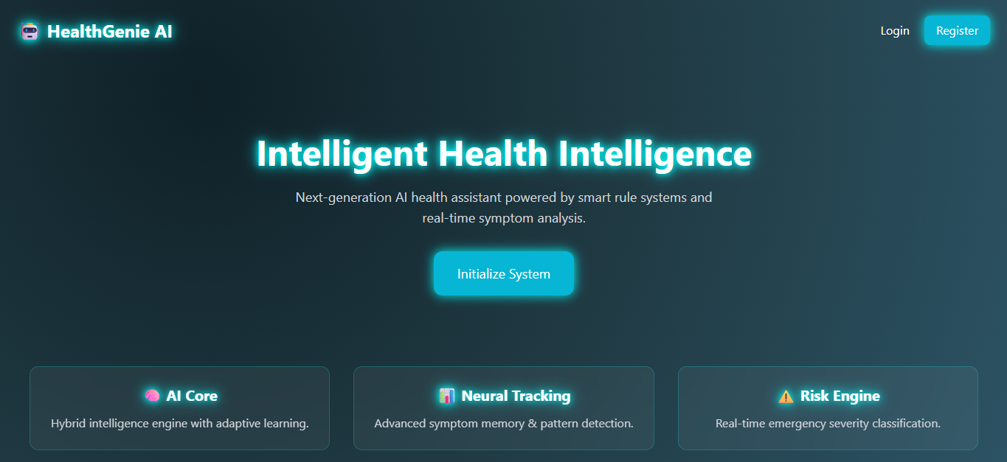

REGISTER PAGE

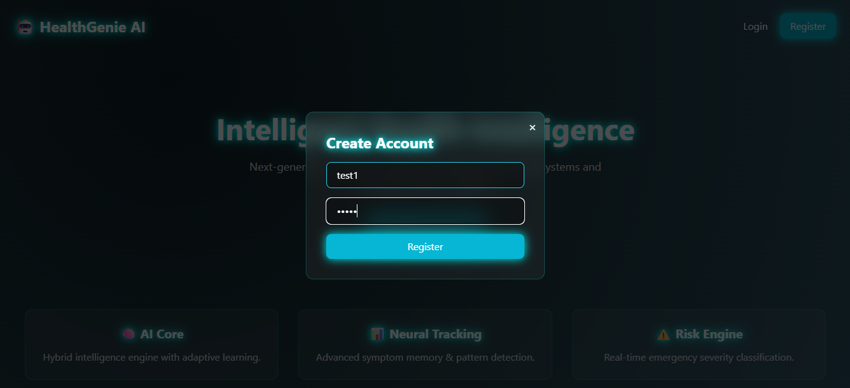

LOGIN PAGE
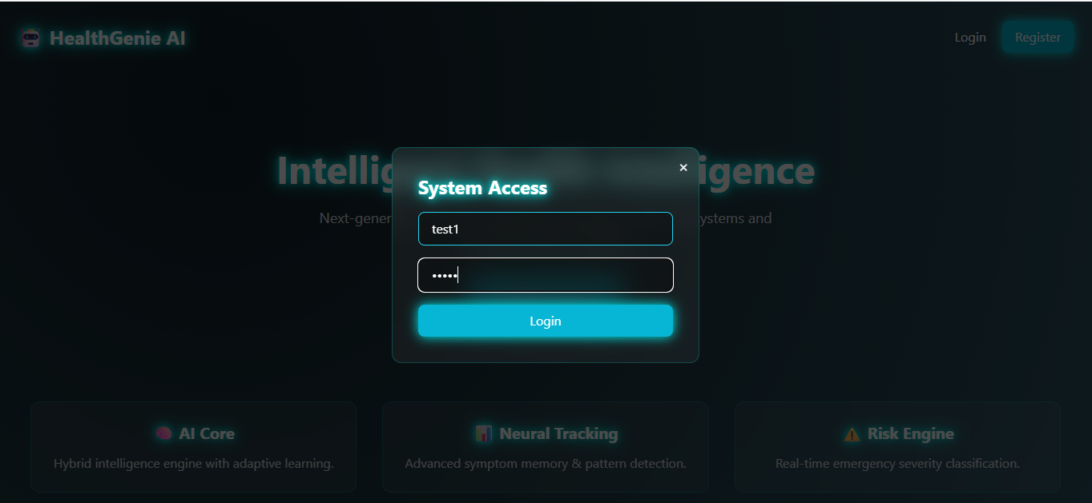
DASHBOARD
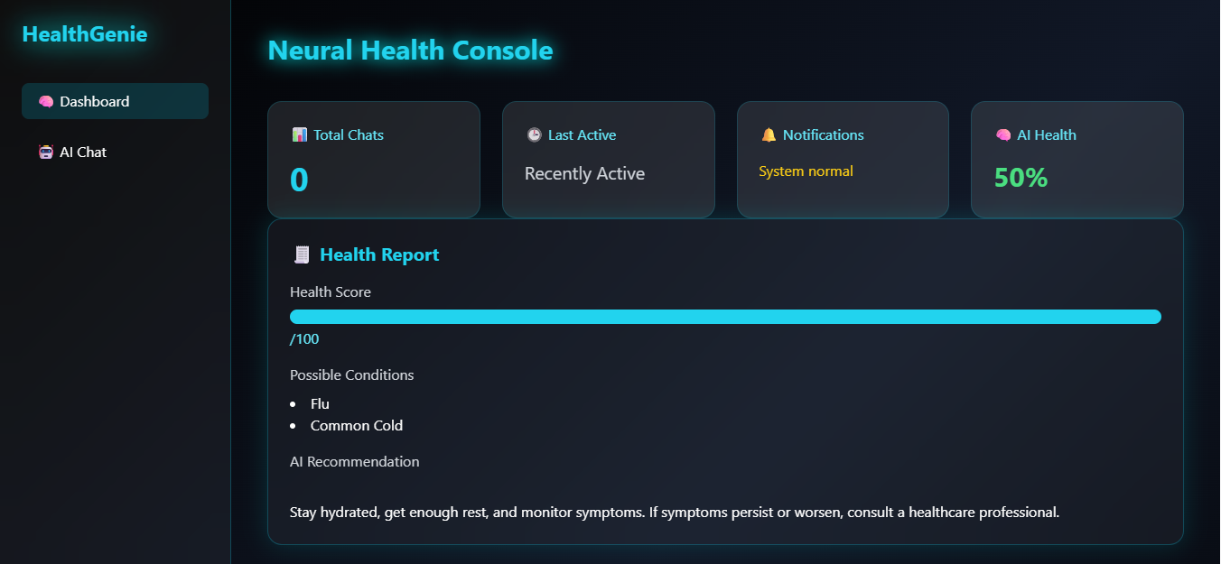

WEEKLY CHAT ACTIVITY CHART
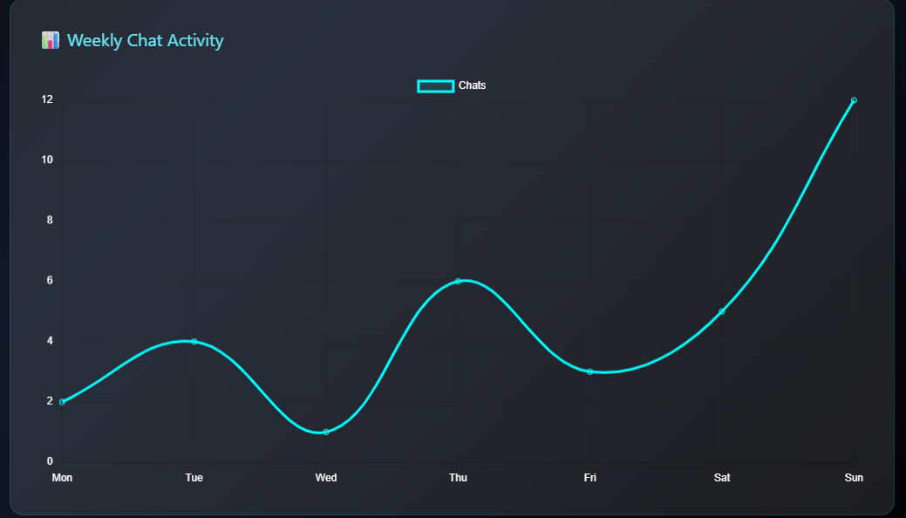
CHAT WITH AI CONSULTANT
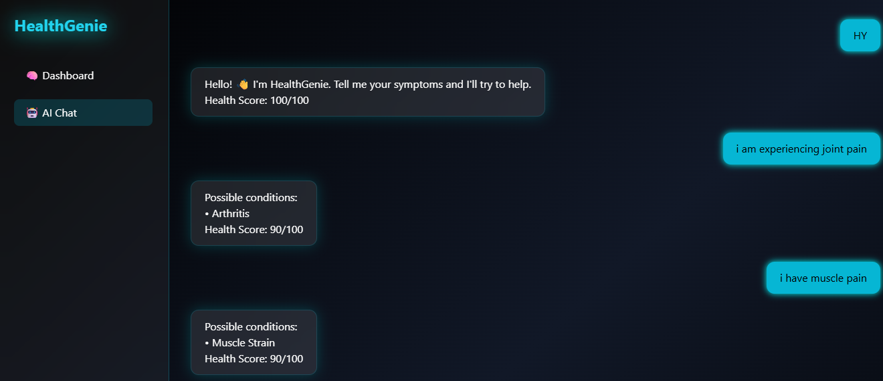

ADMIN PANEL IN DASHBOARD FOR ADMIN ONLY
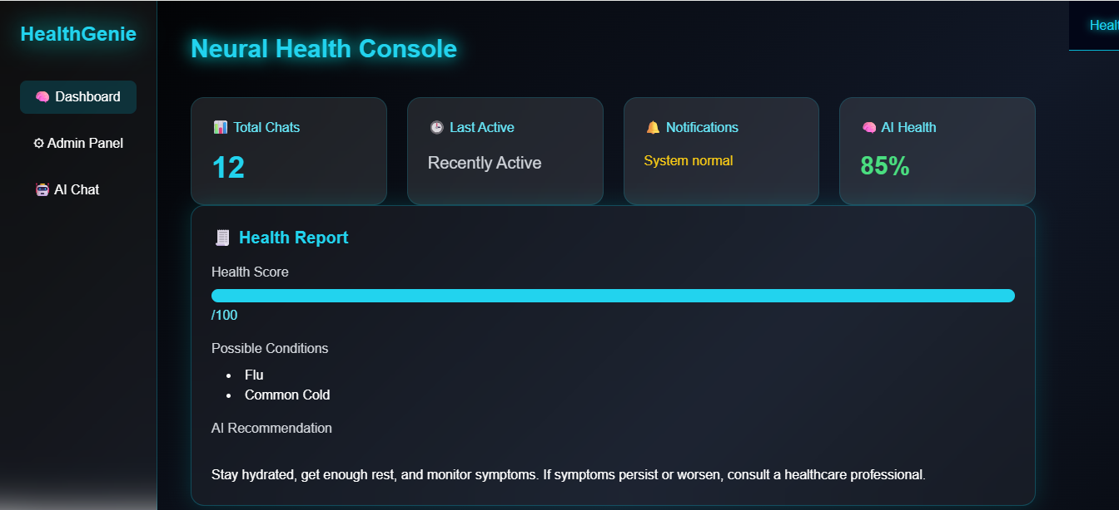
ADIN PANEL
